Wires
- Power wires carry DC signals, so the concept of wire delay does not exist, once they reached all blocks there is no need to care about delay (unlike signals and clocks).
- Metal wires are the type of wires mostly used.
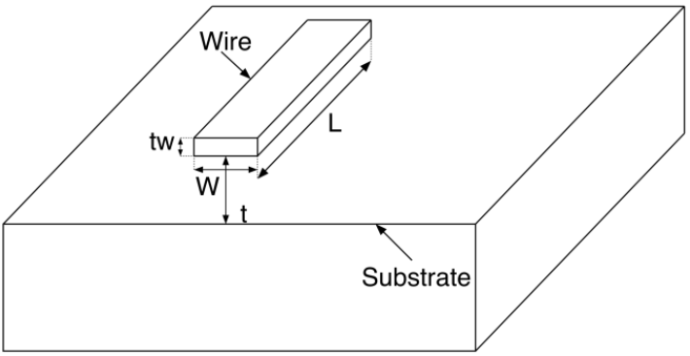

Substrate Capacitance
$$C_{wire}=\frac{ϵA}{d}=\frac{ϵ_{o}ϵ_{r}WL}{t}$$
where $ϵ_{r}$ is the relative permittivity of the insulator used.
- Which parameters in the capacitance equation we can use to decrease the wire capacitance?
𝑊: for sure we want to decrease it, but there is a minimum length for 𝑊 defined by the technology’s DRCs.
𝐿: for sure we want to decrease it, but it is not in our hand, it depends on the placement and routing that took place for the different blocks, once it is made the wire length is defined and cannot be decreased.
𝑡: defined by the technology and fab, so to change it we need to change the technology or the fab.
$ϵ_{r}$: it is easy to say “let’s use polyethylene for example since its 𝜖𝑟 is relatively small”. However, it is easier to fabricate using silicon dioxide, so it is the insulator usually used.
- Which parameters are technology parameters, and which are design parameters?
$$C=\frac{ϵ_{o}ϵ_{r}WL}{t}=\left\{\frac{ϵ_{o}ϵ_{r}}{t}\right\}\left\{WL\right\}=C_{a}\left(WL\right)$$
$C_{a}:$ capacitance per unit area. This is the technology parameter (all wires in the same metal layer have the same $C_{a}$).
$WL:$ design parameter.

Resistance
$$R=\frac{ρL}{A}=\frac{L}{σWt_{w}}$$
- Which parameters are technology parameters, and which are design parameters?
$$R=\left\{\frac{1}{σt_{w}}\right\}\left\{\frac{L}{W}\right\}=R_{s}\left\{\frac{L}{W}\right\}$$
$R_{s}:$square/sheet resistance.
- The resistance of metal wires is no longer negligible in modern technologies due to:
  - Skin effect.
  - Scaling of wires.
- Skin effect: as technology increases, frequency increases. DC currents flow through the whole cross section of a wire. As the frequency increases, the skin depth in which the current moves decreases, which accordingly increases the wire’s resistance. Simplified model:
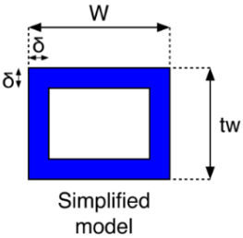
$$A_{eff}=2δW+2δt_{w}-4δ^{2}$$
$$R_{eff}=\frac{L}{σA_{eff}}$$
$$δ=\sqrt{\frac{1}{πμfσ}}$$
From the simplified model, skin effect takes place when:
$$δ<\frac{1}{2}.\min\left(W,t_{w}\right)$$
$$∴f_{min}=\frac{4}{πμσ.m{in}^{2}\left(W,t_{w}\right)}$$

- Scaling of Wires: as technology advances, short wires maintain the same delay while global wires’ delay increase significantly. Why?
Short Wires Long Wires
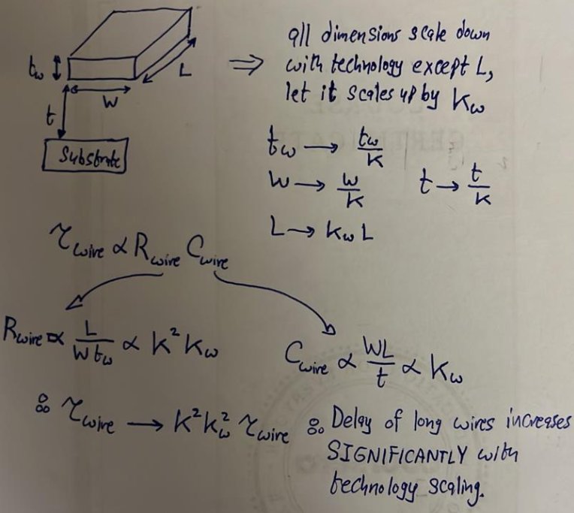
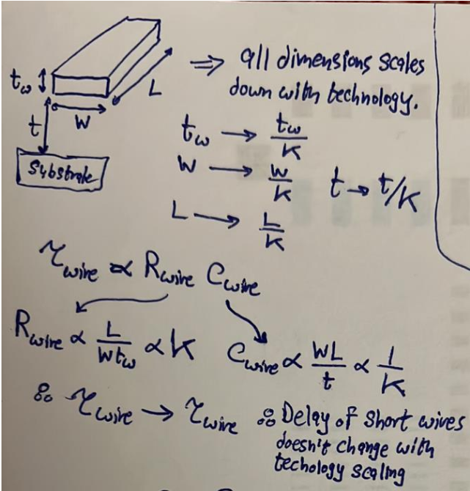

Interwire Capacitance
- It is a capacitance originated between two adjacent wires as shown below:
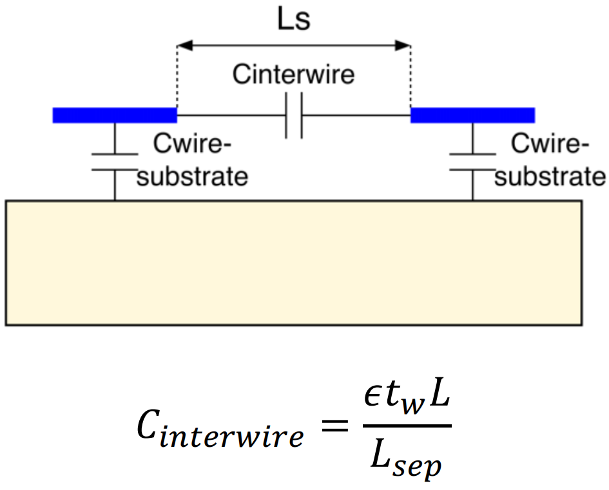
$L:$ common length between the two wires.
- Notice that $R_{wire}$ kan nefsaha el thickness tezeed, while $C_{interwire}$ nefsaha el thickness ye2el. Thus, makansh asa7 qarar enena ma3 el technology advancements ne scale down el thickness bta3 l wires 3ashan keda $C_{interwire}$ hayzeed. Tab ne3mel eh 3ashan nerdy el tarafeen?

Hierarchical Routing
Kol ma hane3la fel metal layers, kol ma hanzawed el thickness beta3 el wires b7ees ne2alel el resistance beta3et-hom and hence use them for global routing. Bs keda el interwire capacitance mabenhom hatzeed? w 3ashan keda hanzawed kaman el separation mabenhom b7ees ne balance el denya. This way, wires in the upper metal layers have less resistance and hence can be used for global routing, while wires in lower metal layers are used for local routing. El shakl hayeb2a as shown below.
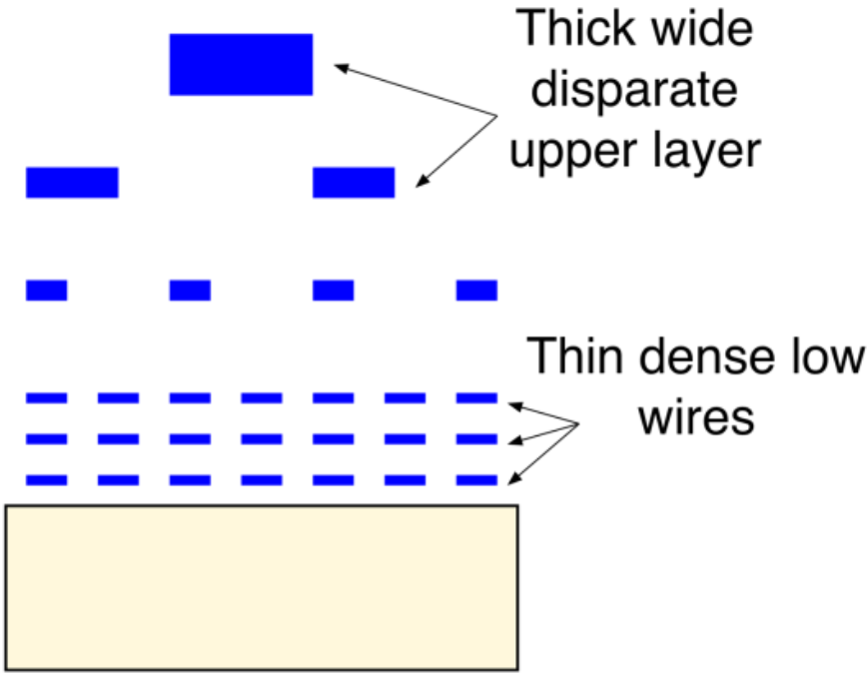

Modeling Wires in Delay Calculation
- El sa7 howa enena ne model el wire as an infinite number of pi sections as shown below:
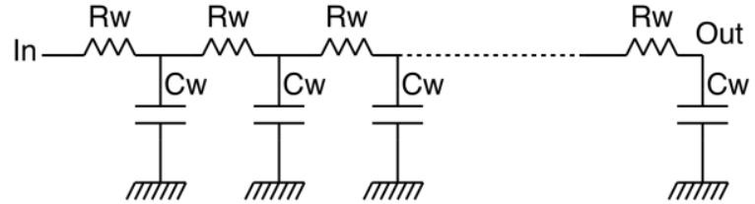
- For simplicity, we will model it as a single pi section bs with a divided capacitance as shown below:
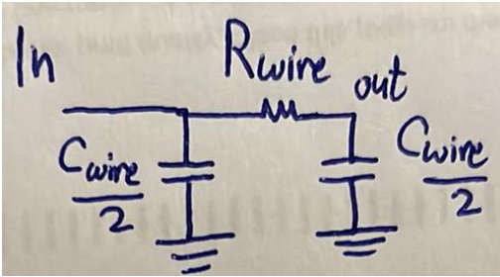
- Example of calculating the delay of an inverter (driver) with and without including wires delay:
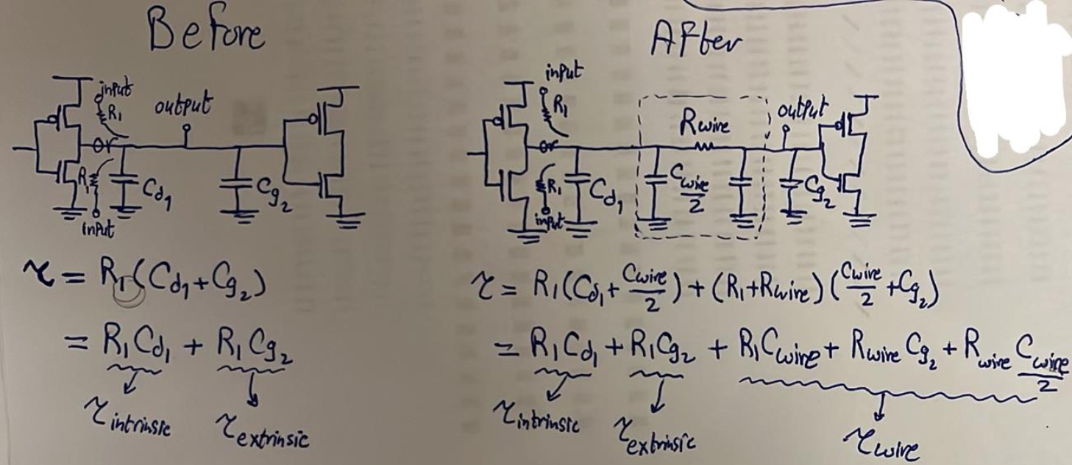
Notice enena bene7seb el time constant at the input of the second gate not the output of the first gate because this is what really matters.

Supply and Ground Bounce
- $V_{DD}$ and ground pins of a chip suffer from inductances to the supply and ground sources as shown below. Since these pins see large variation in current and $V_{inductance}=L\frac{dI}{dt}$, the voltage drop on the inductors can be large, which might cause $V_{DD}$ to decrease and ground to increase, causing noise margins to decrease.
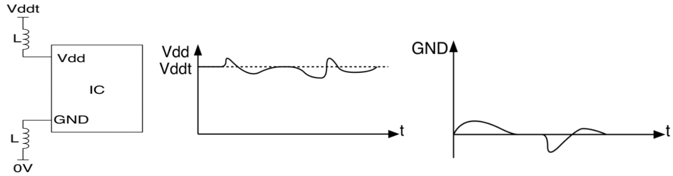
- One solution is to place a capacitor between the two pins as shown below. El capacitor haye3mel eh? wel signal 5arga metganena men el $V_{DD}$ wel ground pins be frequency 3alya, el impedance beta3t el capacitor hateb2a soghayara w bel taly haya5od el signal de ye5aleha 3ando. Awel ma el frequency tesghar, terga3 el seka bta3t el inductors of low impedance tany, fa troo7 el signal safely lel $V_{DDt}$ aw $0V$.
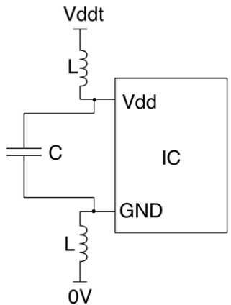
Eb2a erza3lo el kam rasma dool bardo:
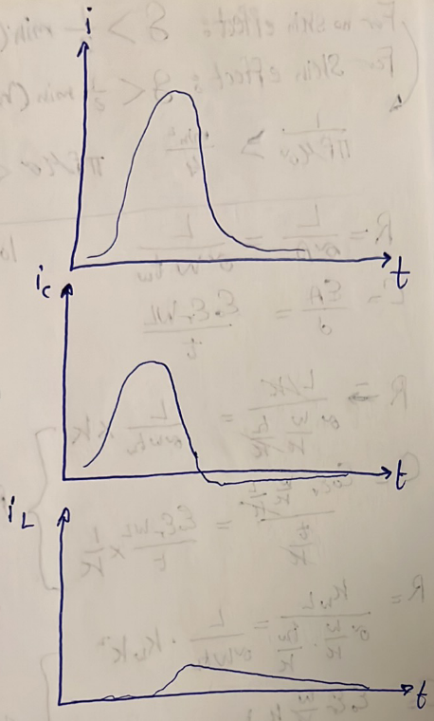

Clocks
- Clock signal suffers from a large capacitance due to the capacitance seen from many flip flops AS WELL AS the capacitance of the clock wires themselves. The solution is to use a large buffer in the clock path.
- Lw el tool 3andaha el e5tyaar te5tar bera7et-ha mabeen positive w negative skew, hate5tar meen? most of the times hate5tar el negative skew mesh el positive skew. Leeh? la2en lw baseet 3la el equation beta3et el setup analysis wel hold analysis, hatla2y en el clock period $T$ zahra fi el setup equation bs, mesh zahra fi el hold equation. El fekra b2a en el $T$de beteb2a akbar bekteer men qemet el skew $δ$, fa en e7na nedeef el $δ$ de fi equation el setup sawa2 be tare2a tesa3do aw tare2a tedoro actually mesh betefre2 keteer la2enaha almost negligible bel nesba lel $T$. On the other hand b2a, el $T$mesh beteb2a mawgooda fi equation el hold, fa el times el da5la fi equation el hold beteb2a mesh kebera awy, fa el $δ$ beyeb2a leha ta2seer actually fi el equation bta3t el hold. Fa 3ashan keda el tool bete5tar el $δ$ such that enaha tesa3ed el hold equation, el howa enaha te5tar negative skew!
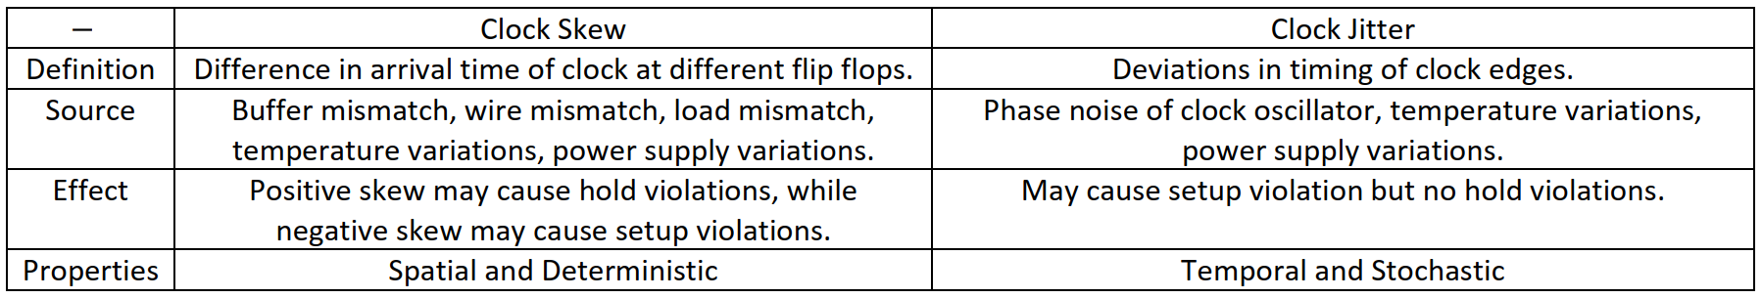
- If the data and clock are moving in the same direction —> positive skew.
- Question: why doesn’t jitter have any impact on hold time?
Answer: because hold-time analysis is done on one clock edge, so even
if jitter moves the active edge, it moves it for all registers simultaneously. Thus, regardless of the position of the edge, no new holdtime violations can occur. Skew had the potential to create new hold-time violations because it caused different registers to observe different clocks.
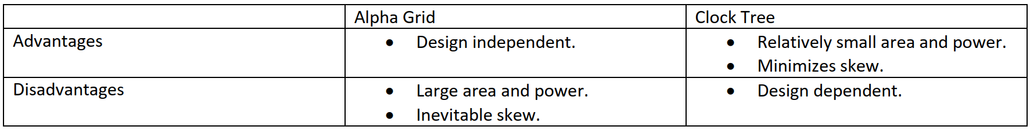
- Hybrid clock distribution is used in large designs. For example, when making a transceiver, the transmitter can be allocated a grid and the receiver can be allocated another grid.

Latches

Timing in Latches
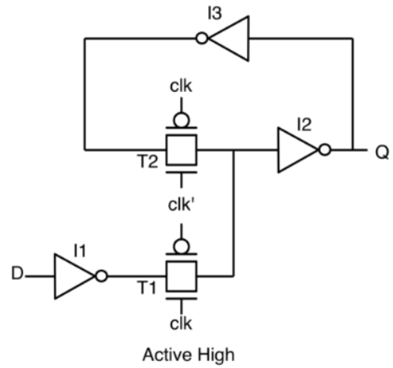
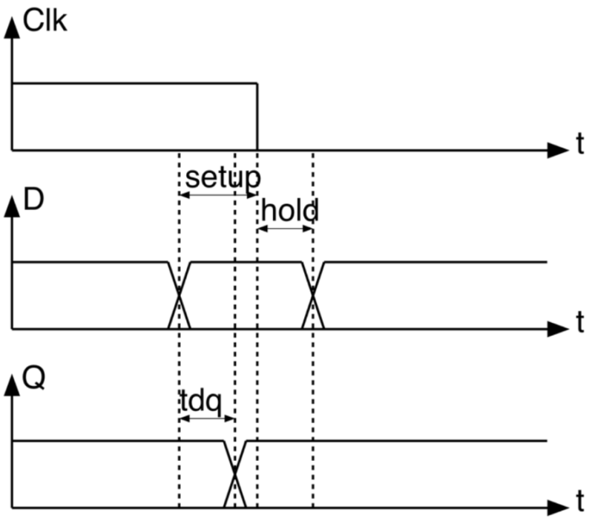
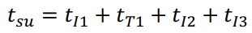
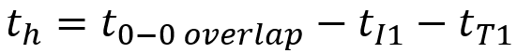
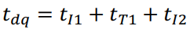
- VIP: fl flip flops el violations bt7sal 7awaleen el active edge, fel latches el violations bete7sal 3and nehayt el active level!!!!!
- El sa7 howa en kol stage ta7tarem nafsaha w t5ls fi wa2t $\frac{T_{clk}}{2}$ maximum. Tyb y3ny eh ta7tarem nafsaha? y3ny el wa2t el heya beta5do 3ashan tewasal el output beta3ha lel stage el ba3deha may3adesh $\frac{T_{clk}}{2}$. Tab eh el wa2t el ay stage beta5do? $t_{dq}+t_{CLB,max}$. Ay wa2t zeyada el stage de hata5do hayo3tabar borrowing, w bel taly $t_{borrow}=t_{dq}+t_{CLB,max}-\frac{T_{clk}}{2}$.
- For a correct operation of a latch loop, for each stage j:
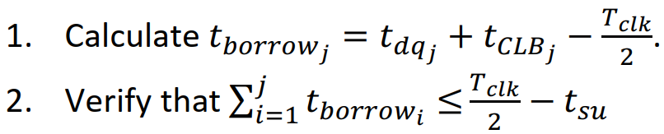
- Why don’t we use latches in our design?
- Data has only $\frac{T_{clk}}{2}$ to propagate from one latch to another, while flip flops allows data to propagate in $T_{clk}-t_{su}$.
- Being level triggered, latches are vulnerable to glitches.
- Place and route tools find it harder to achieve timing closure in latch-based designs.

Clock Domain Crossing
- Two clocks are said to be in two different domains if they do not have a constant phase relationship. To have a constant phase relationship, the two clocks must:
  - be generated from the same clock source.
  - have frequencies that are multiple integers from each other.

How does a flip flop behave when it goes metastable?
- Metastability means that one of the following scenarios happened at the output of a flip flop:
  - The output remained unchanged until the next clock cycle (when the input changes very near to the edge).
  - The output glitched and returned back to its original value (when the input changes in the middle of the setup window).
  - The output changed to the correct value but at a wrong time (when the input changes just after the setup window begins).
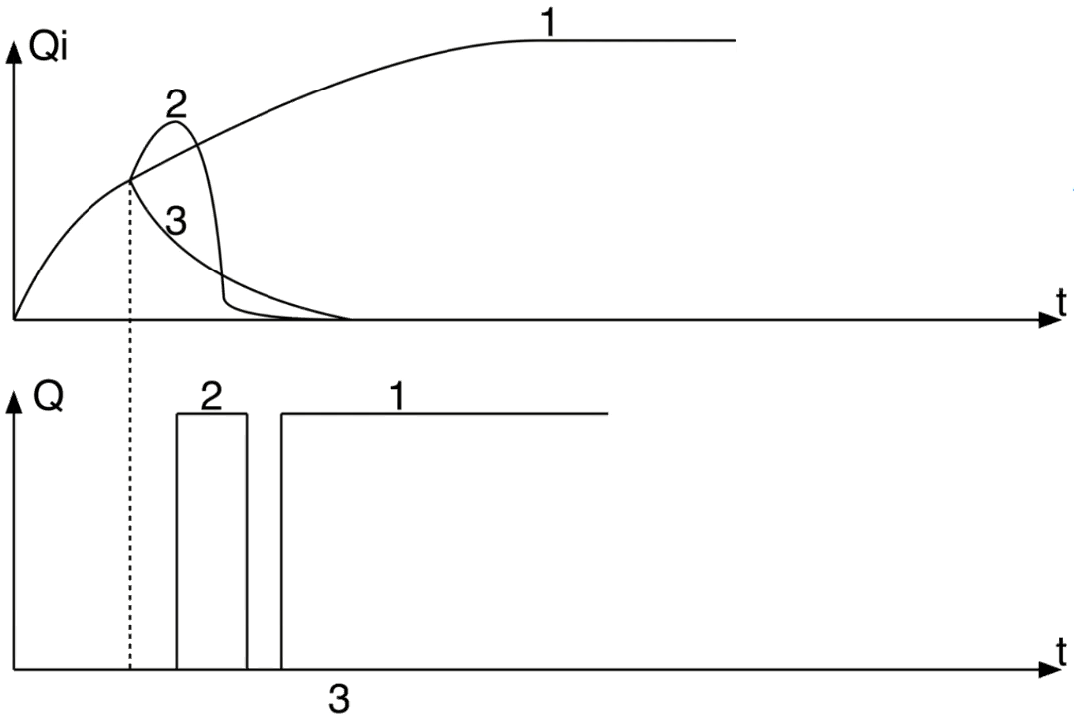
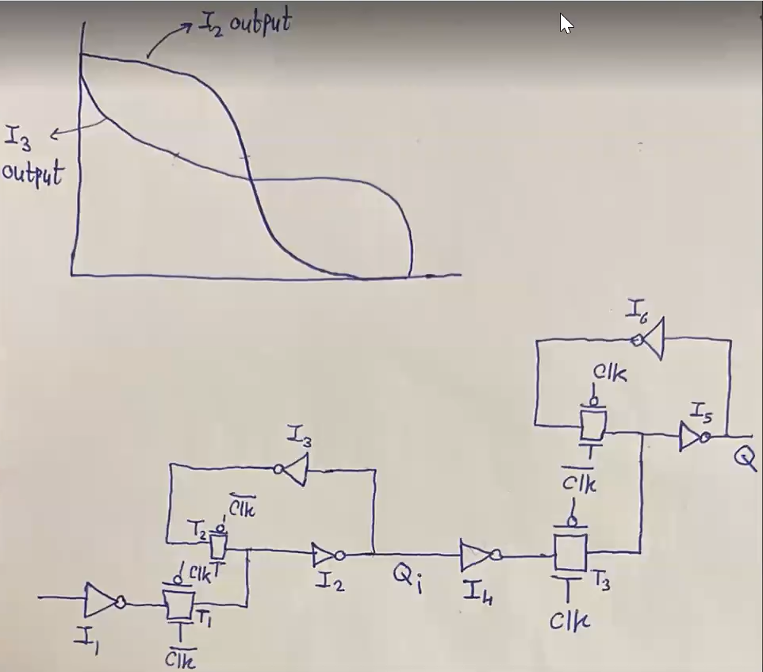
Lw nasy erga3 shoof video 1 fi lecture el CDC.

How often does metastability occur?
$$P\left(metastability\right)=\frac{T_{m}}{T_{2}}$$
$$MTBF{\left.​\right|}_{before synchronizer}=\frac{T_{1}T_{2}}{T_{m}}$$

How long does it take a flip flop to get out of metastability?
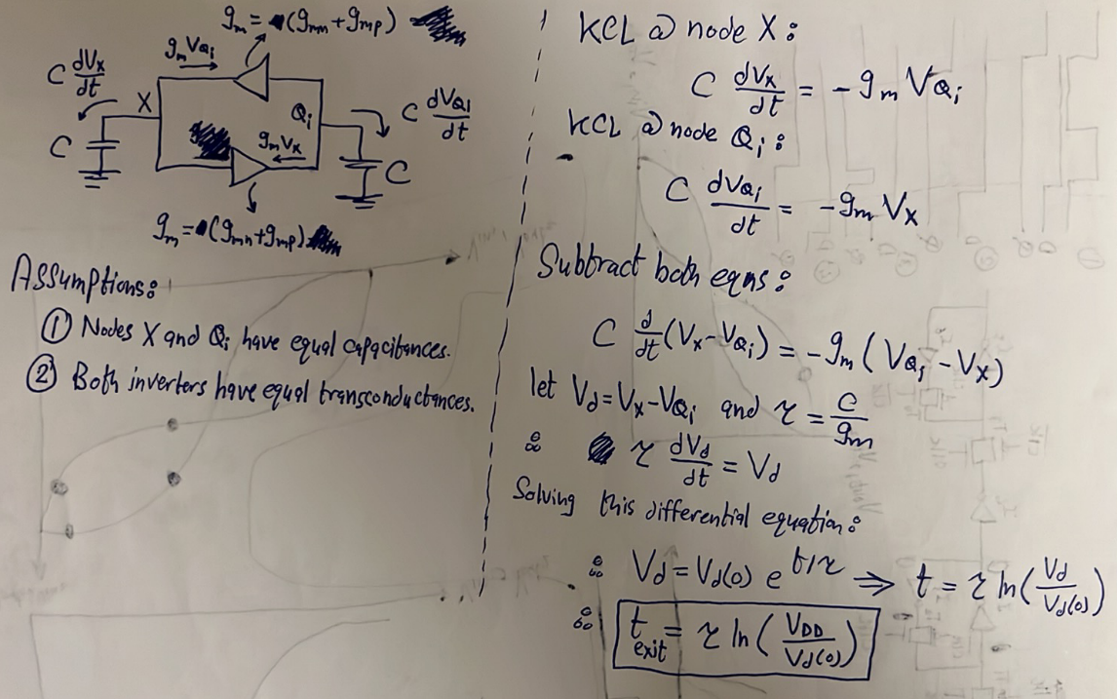
$$P\left(still in metastability after time t \right| metastability occured)=e^{-\frac{t}{τ}}$$
$$P\left(enters metastability ∩remains in metastability after time t\right)=\frac{T_{m}}{T_{2}}*e^{-\frac{t}{τ}}$$
$$P\left(enters metastability ∩remains in metastability after time T_{2}\right)=\frac{T_{m}}{T_{2}}*e^{-T_{2}/τ}$$
$$R\left(enters metastability ∩remains in metastability after time T_{2}\right)=\frac{T_{m}}{T_{1}T_{2}}*e^{-T_{2}/τ}$$
$$MTBF{\left.​\right|}_{after synchronizer}=\frac{T_{1}T_{2}}{T_{m}}*e^{T_{2}/τ}$$

How to handle/solve metastability?
- For a single bit, use a double flop synchronizer. Notice that it will have a one-cycle uncertainty.
- For a gray counter, use multiple double flop synchronizers. Why can’t we use multiple double flop with non-gray-counter buses? because garbage value might exist on the bus. Check the example below.

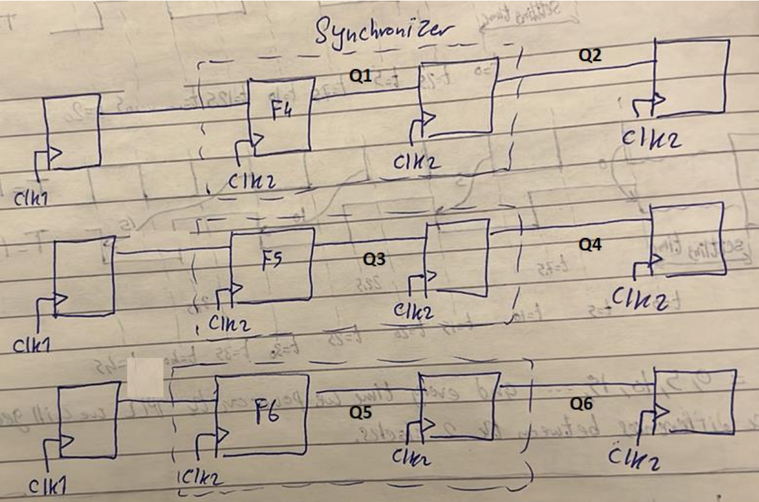
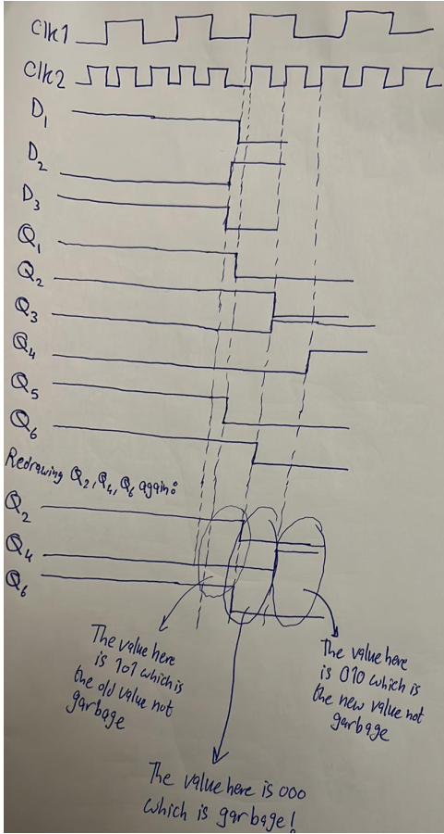
- For non-gray-counter buses, handshaking synchronizers should be used.
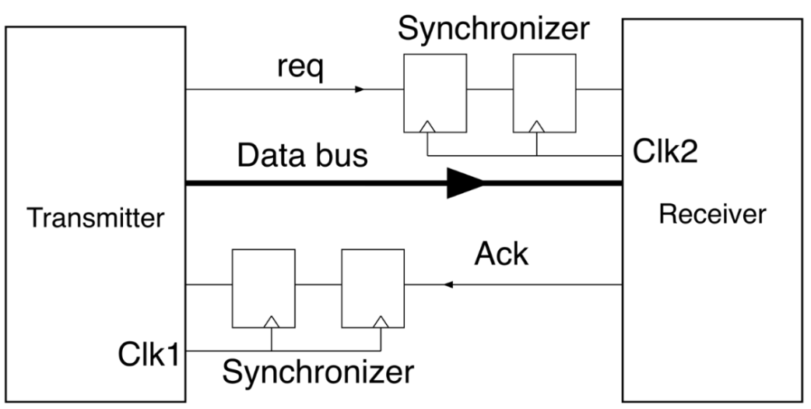
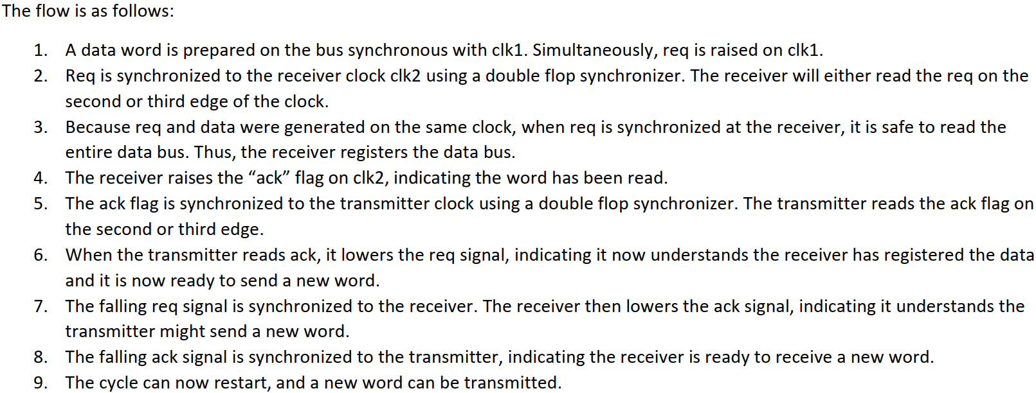
- Notice that too many clock cycles are wasted just to transmit one word of data from domain 1 to domain 2. As a result, using handshaking synchronization is only applicable when the transmitter and receiver communicate with each other occasionally.
- Another way to transfer data from a fast domain to a slow domain is using an asynchronous FIFO. One is shown below:
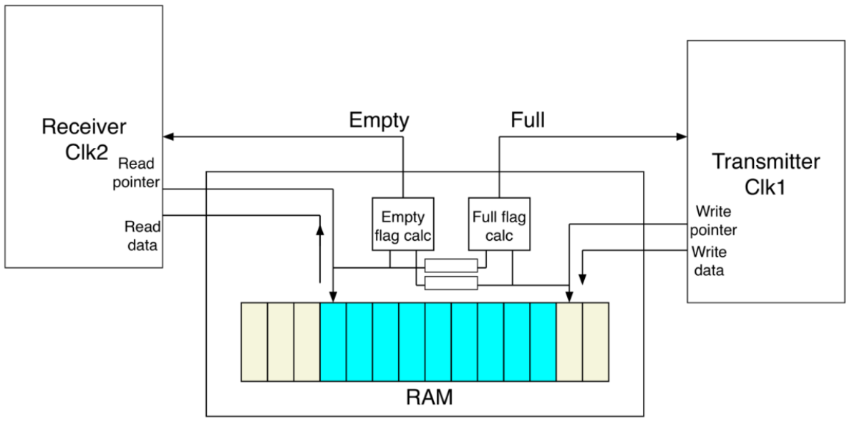

Adders

Ripple Carry Adder
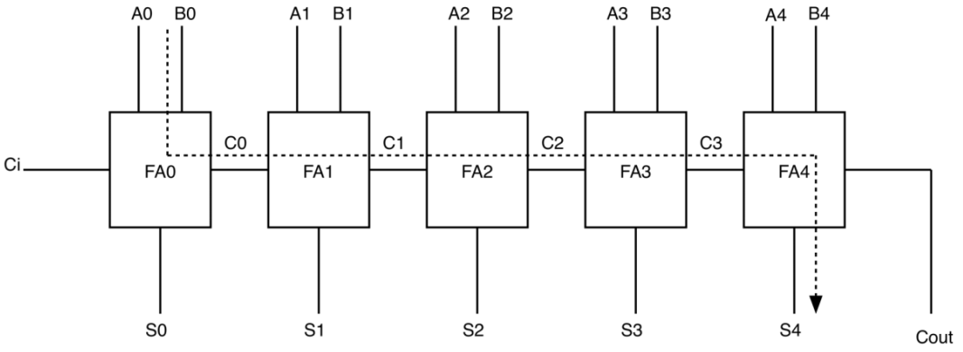
$$T_{delay}=\left(N-1\right)T_{carry}+T_{sum}$$
- Delay grows linearly.

Ripple Carry Adder With Generate and Propagate Logic
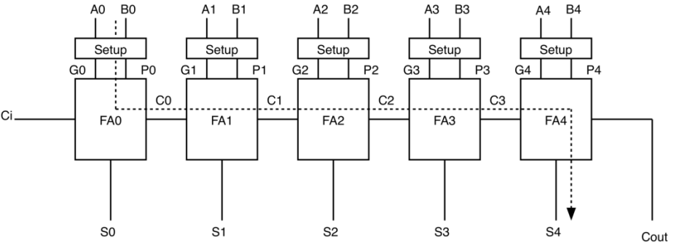
$$T_{delay}=T_{gp}+\left(N-1\right)T_{carry}+T_{sum}$$
where:
- $T_{gp}$is the delay to calculate $G$and $P$in parallel.
- $T_{sum}=P^C_{in}$
- $T_{carry}=G+P.C_{in}$
- $G=AB$
- $P=A ^ B$
- $D=A^{'}B'$

Manchester Carry Chain
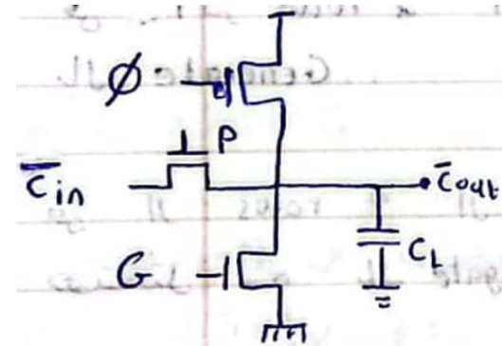
- Cascading results in an RC ladder, so the solution is to separate between each two stages using static buffers.

Carry Bypass Adder
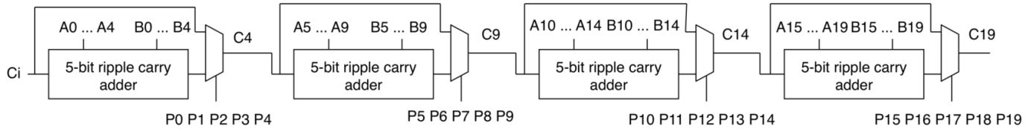
- Delay growth is still linear but with a lower slope compared to the ripple carry adder.
- The optimal value of $K$is:
$$K=\sqrt{\frac{N}{2}.\frac{T_{mux}}{T_{carry}}}$$

Carry Select Adder
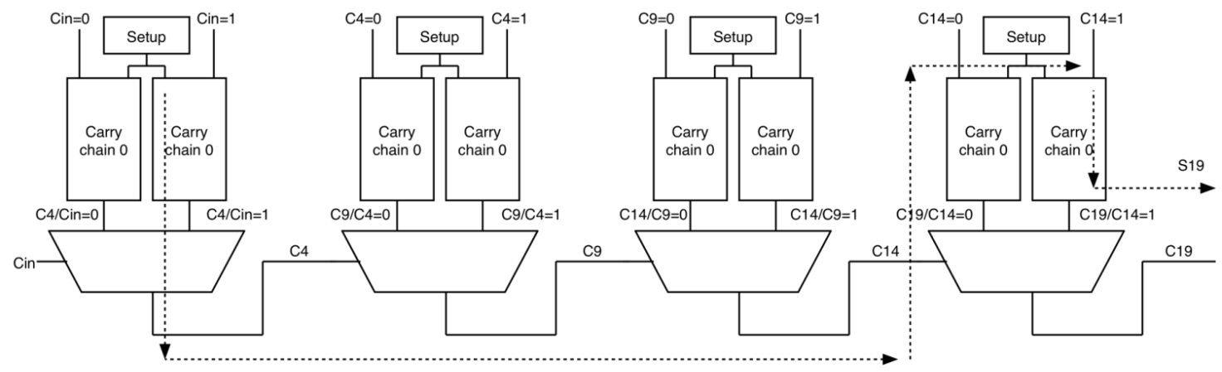
- If all the stages have equal number of bits $→$same delay as carry bypass adder.
- If stage 1 has $K$bits, stage 2 has $K+1$bits, and so on, then for $P$ stages and using one chain in the first stage, the delay is:
$$T_{add}=T_{gp}+KT_{carry}+\left(P-2\right)T_{mux}+\left(K+P-2\right)T_{carry}+T_{sum}$$
$$N=\left(K\right)+\left(K+1\right)+\left(K+2\right)+…+\left(K+P-1\right)=\frac{P(2K+P-1)}{2}$$
$$For P≫K$$
$$N≈\frac{P^{2}}{2}→P=\sqrt{2N}$$
$$T_{add}=T_{gp}+KT_{carry}+\left(\sqrt{2N}-2\right)T_{mux}+\left(K+\sqrt{2N}-2\right)T_{carry}+T_{sum}$$
- Delay growth is square root.

Carry Lookahead Adder
- In this type of adder, we expand the expression of all carries and calculate each of them as shown below.
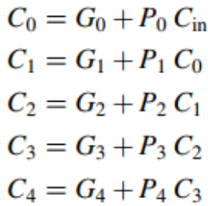

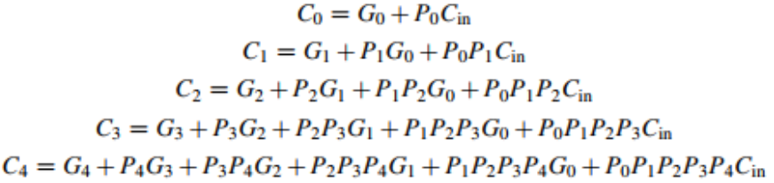
- The delay growth is quadratic.

Group Generates and Propagates
- For the carry expressions below, each expression consists of group propagate, which is the last term without $C_{in}$, and group generate, which is the rest of the terms.

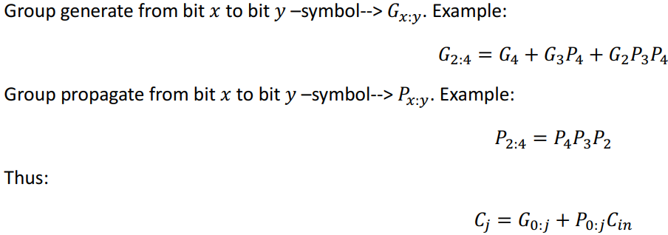
- Dot operator properties:
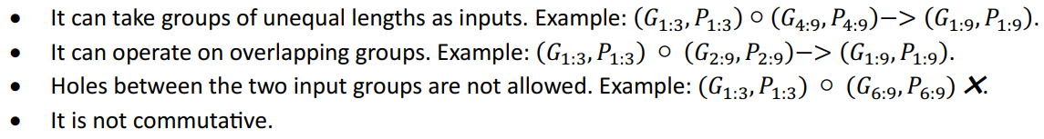
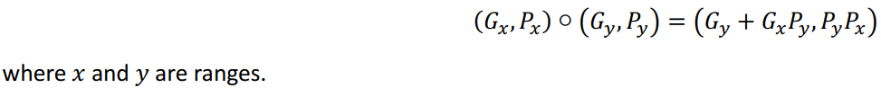

Kogge Stone Adder
- Delwa2ty e7na 3ashan n2ool en el adder 5alaset, me7tageen kol el gy yeb2a et7asab:
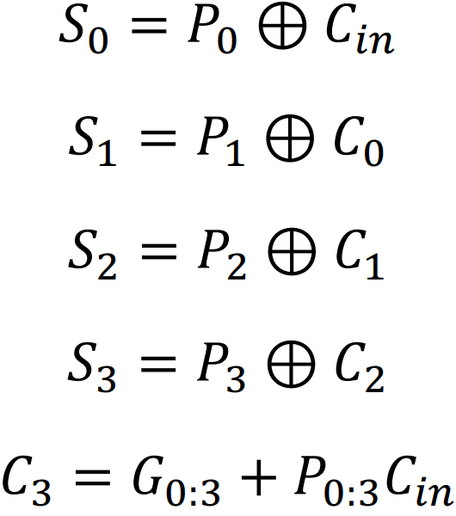
$P_{0}→P_{3}$w $C_{in}$ kolohom m3ana from time 0. Keda fadel $C_{0},C_{1},C_{2},G_{0:3},P_{0:3}$. $C_{0}→C_{2}$ are given by:
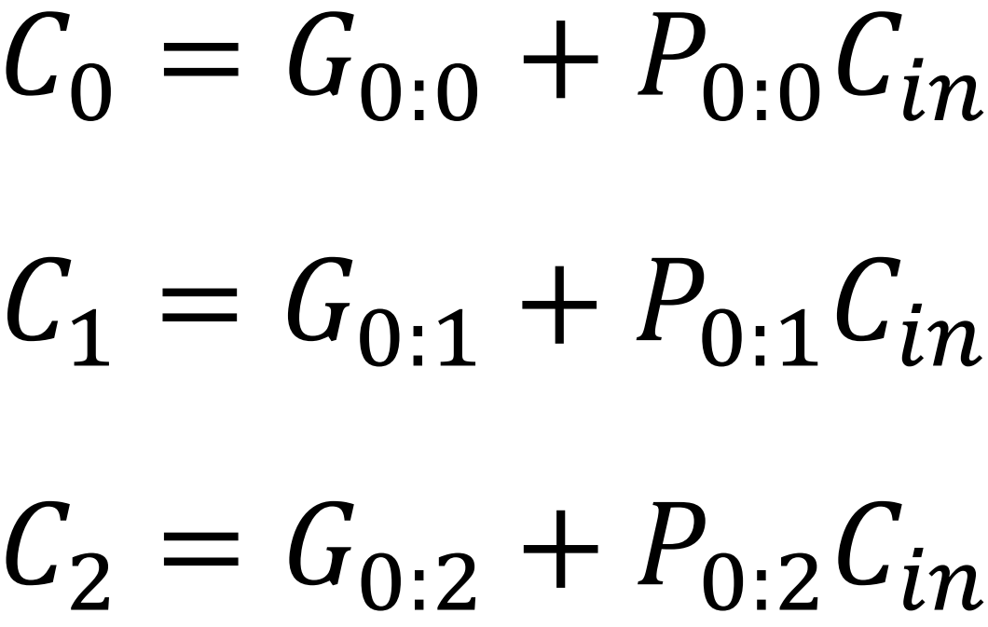
- Example of an 8-bit adder:
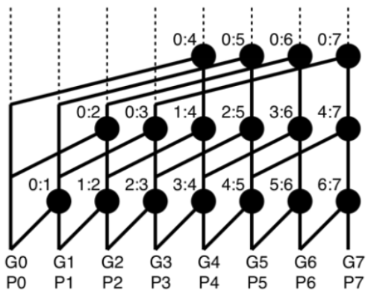
- The critical path has a delay of an N-bit Kogge Stone adder is ⌈$\log_{2}\left(N\right)⌉*T_{dot}$.
- Delay growth is $l{og}_{2}\left(N\right).$

Brent Kung Adders
- Benkawen akbar range el awel, then nshoof eh el na2esna w ne3melo.
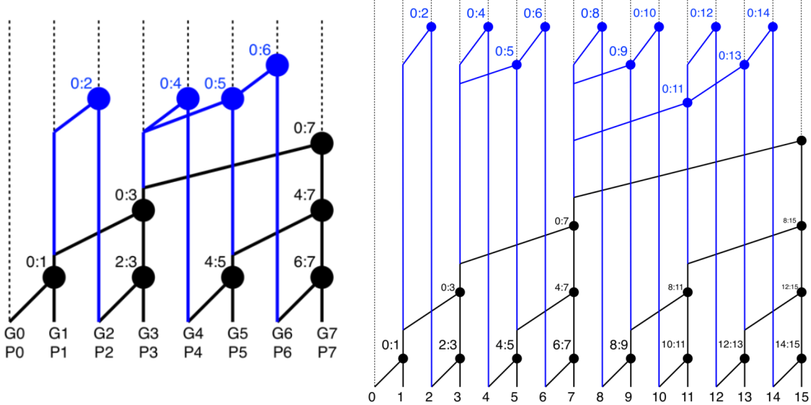
$$-$$ | Kogge Stone Adder | Brent Kung Adder
Advantages | - Delay growth is $l{og}_{2}(N)$.  - Fanout of each dot operator is maximally 2 dot operators. | - The number of dot operators is less than that of a Kogge Stone adder and hence smaller area.  - Less placement and routing headache than a Kogge Stone adder.
Disadvantages | - Area growth is more than $2N$.  - Large headache for placement and routing tools. | - Delay growth is slightly larger than $l{og}_{2}\left(N\right)$.  - Fanout of each dot operator can be more than 2 dot operators.

Summary:
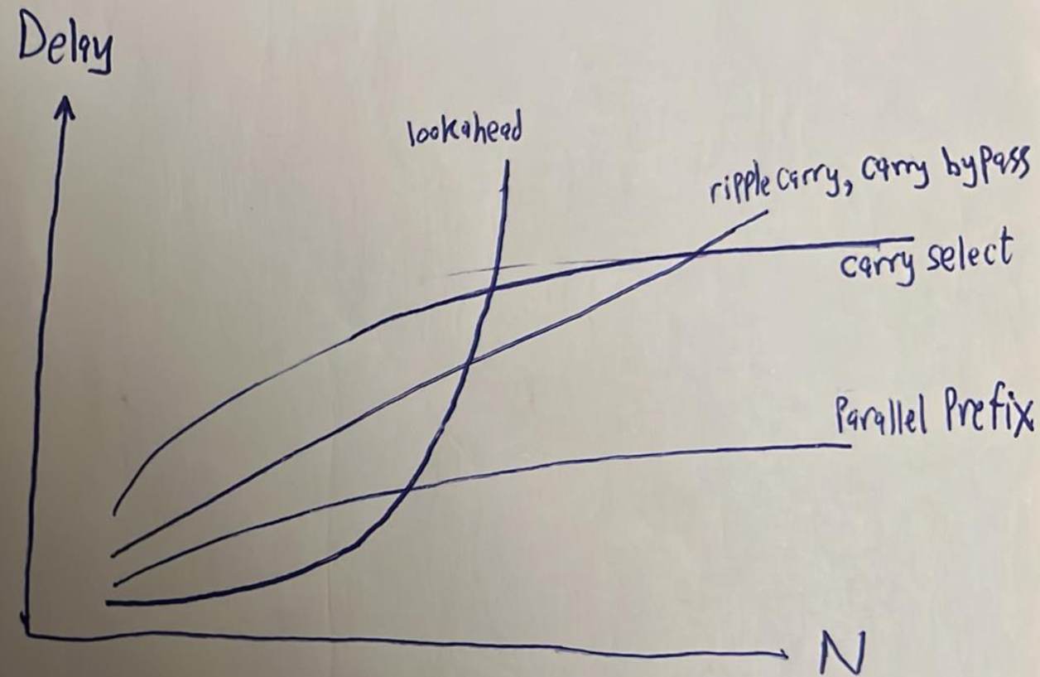

High Level Design (Not Totally Summarized)
- To convert a floating-point number to a fixed-point number stored in n bits on MATLAB:
$$a=rand;$$
$$a=a*\left(2^{n}-1\right);$$
$$a=floor\left(a\right);$$
- SQNR is the ratio between the power of the signal to the power of the quantization noise as follows:
$$SQNR=\frac{{\left(c_noisless\right)}^{2}}{{\left(c_noiseless-c_trunc*2^{p}\right)}^{2}}$$

VHDL (Not Totally Summarized)
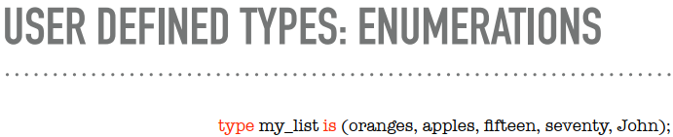
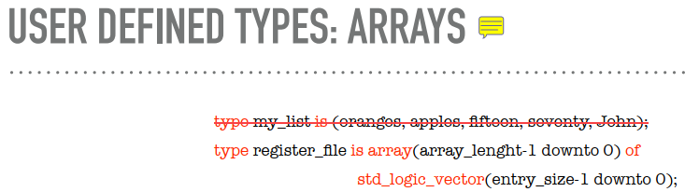
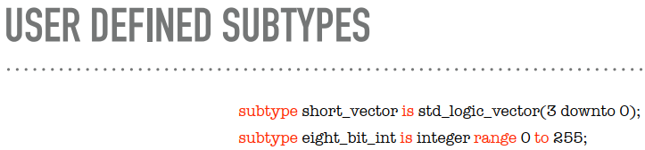
- Assuming there is an entity called sixteen_bit_adder as shown below:
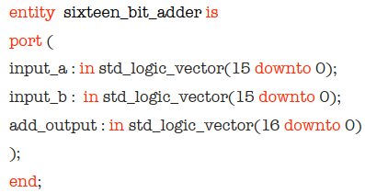
Instantiate an instance of this entity in an architecture (connect its ports to random signals).
Answer:
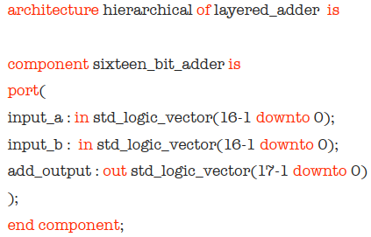
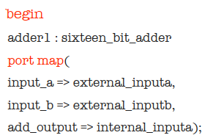
...

- For the same previous entity sixteen_bit_adder, instantiate the following instances:
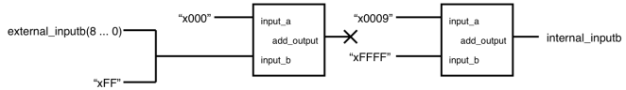
Answer:
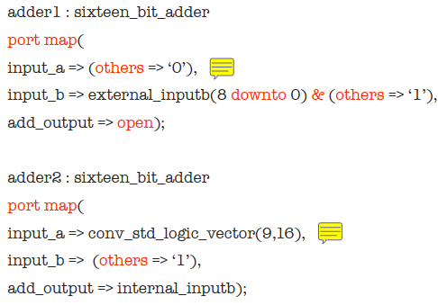
- Selecting a specific architecture:
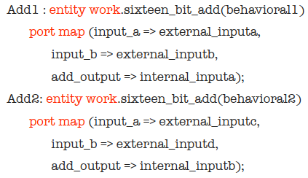
- We can declare constants as follows:
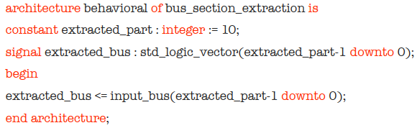
- Generic maps can be declared as follows:
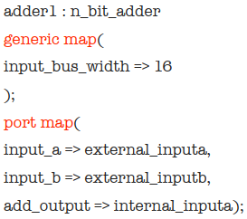
- Bos 3la el when-else wel with select t7t 3ashan lw gom maktobeen bs, mate7fazsh el syntax keda keda mesh hasta5demhom, hab2a akteb case gowa process :D
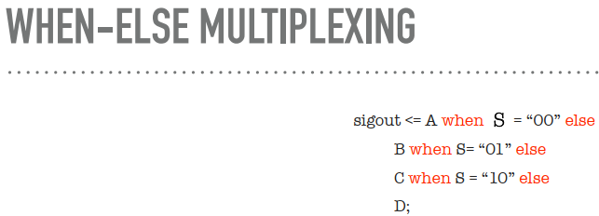
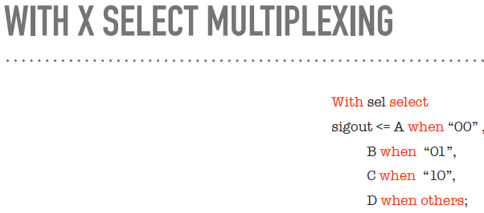
- Some notes about variables:
- Variables are declared inside processes (between process and begin). Example:
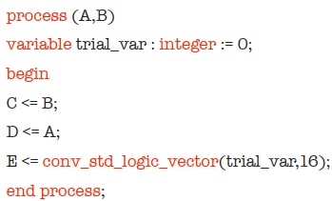
- Variables keep their values from the last call (except for functions!!!! that is, variables do not keep their values between calls).
- Variables are assigned immediately.
- El beyetla3 men el sequence of if-else statements momken yeb2a mux kebeer OR a priority encoder (i.e. a cascade of 2x1 muxes). This depends on the conditions inside the if-else statements. If all the conditions are mutually exclusive, then one big mux is inferred. If they are not mutually exclusive, then a priority encoder is inferred.
- Ekteb two codes, wa7ed beye3mel flip flop with synchronous reset wel tany with asynchronous reset.
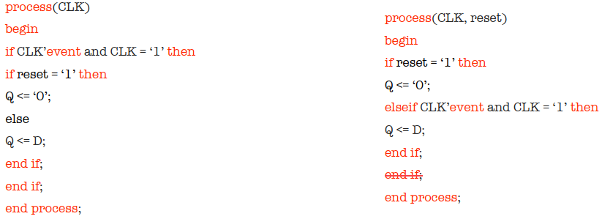
- Ekteb code for a general shift register.
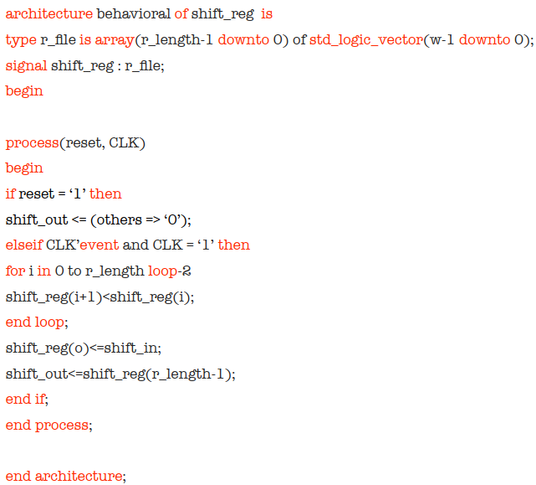
- Write a complete code for the following circuit:
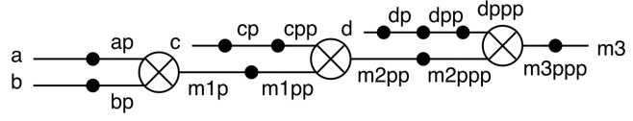

Answer:
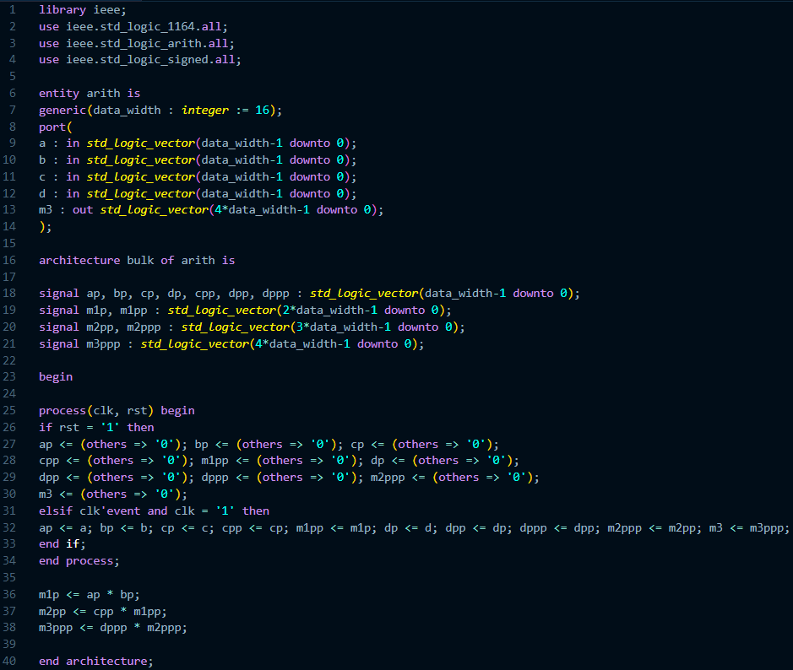
- Write a code for a ROM.
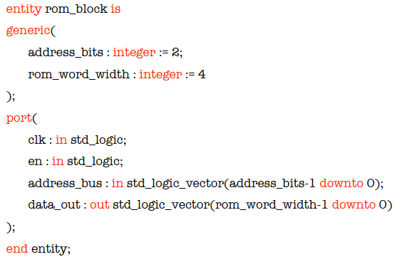
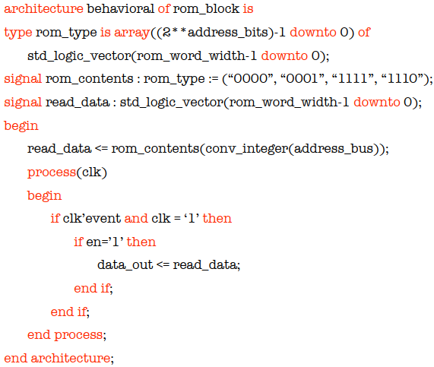

- Write a code for a single-port RAM.
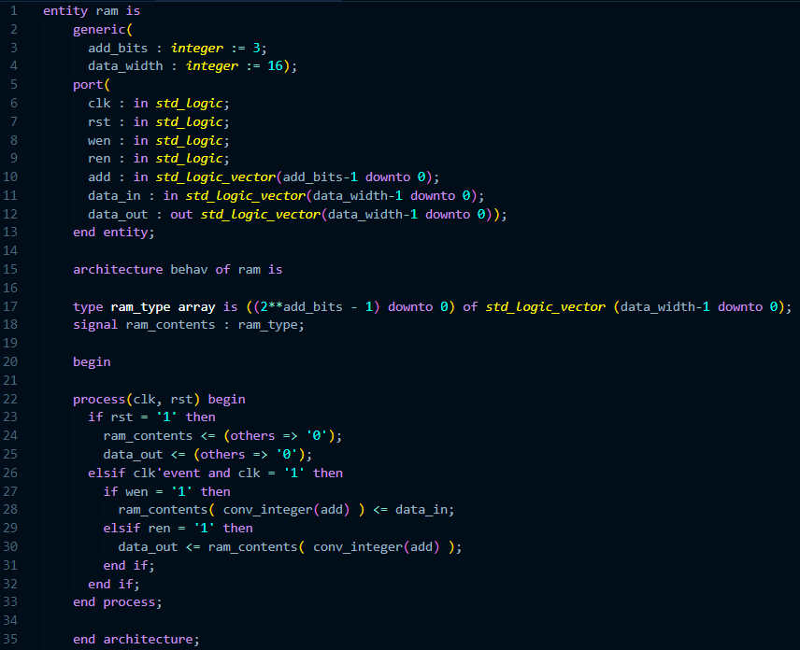
- Check the cases below (note: fi 7alet eno wala bey read wala bey write mesh bey5osh fel code el t7t da aslan, fa data_out hat maintain a5er value leha, register y3ny).
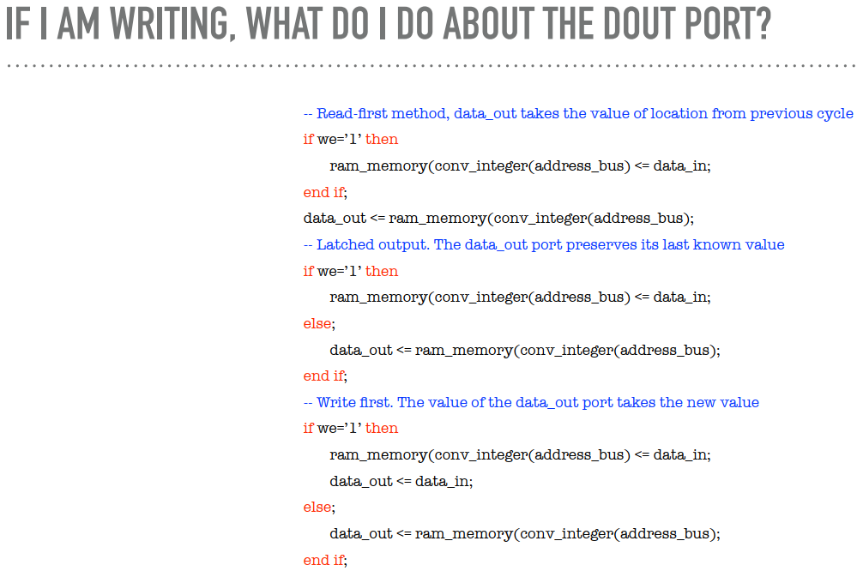

- Note: in case of multi-port memory, you MUST declare the memory as a shared variable, it cannot be a signal. Why? because the synthesis tool doesn’t allow a signal to be assigned in more than one process.

- 3andena 4 types of wait statements:
- wait: not synthesizable.
- wait for: not synthesizable.
- wait until: most probably synthesizable. Example:
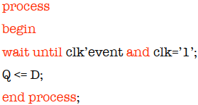
VIP: el example el t7t da bey create flip flops:
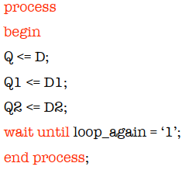
- wait on: de el sensitivity list.
Functions | Procedures
Declared in the declaration part of the architecture. | Declared in the declaration part of the architecture.
All ports are inputs without definition. | Ports can be inputs or outputs.
Must contain a return statement. | Doesn’t contain a return statement.
Use variables only AND THESE VARIABLES DO NOT KEEP THEIR VALUES BETWEEN FUNCTION CALLS. | Can use variables and signals.
To be synthesizable, they must return a constant value. | To be synthesizable, they must return a constant value.
Example:  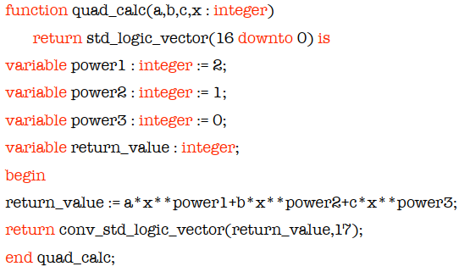 | Example:  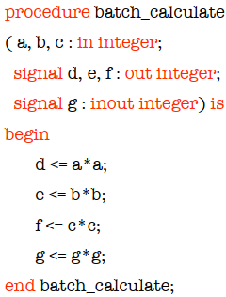

- Why do we use 2’s complement?
- It doesn’t waste two numbers for representing a zero as in 1’s complement and sign-magnitude representations.
- It is more arithmetic-friendly; we can mix positive and negative numbers without any pre-processing.
- Why do we use fixed-point?
Although floating-point arithmetic is more accurate than fixed-point, we usually choose fixed-point over floating-point. Why? The main problem with floating-point is its arithmetic. Floating-point arithmetic requires much more power and processing compared to fixed-point arithmetic.
- Throwing the MSB causes failure in case of overflow, while throwing the LSB causes loss in accuracy in case of an odd result (take care of scaling, throwing the LSB translates to dividing the result by 2.

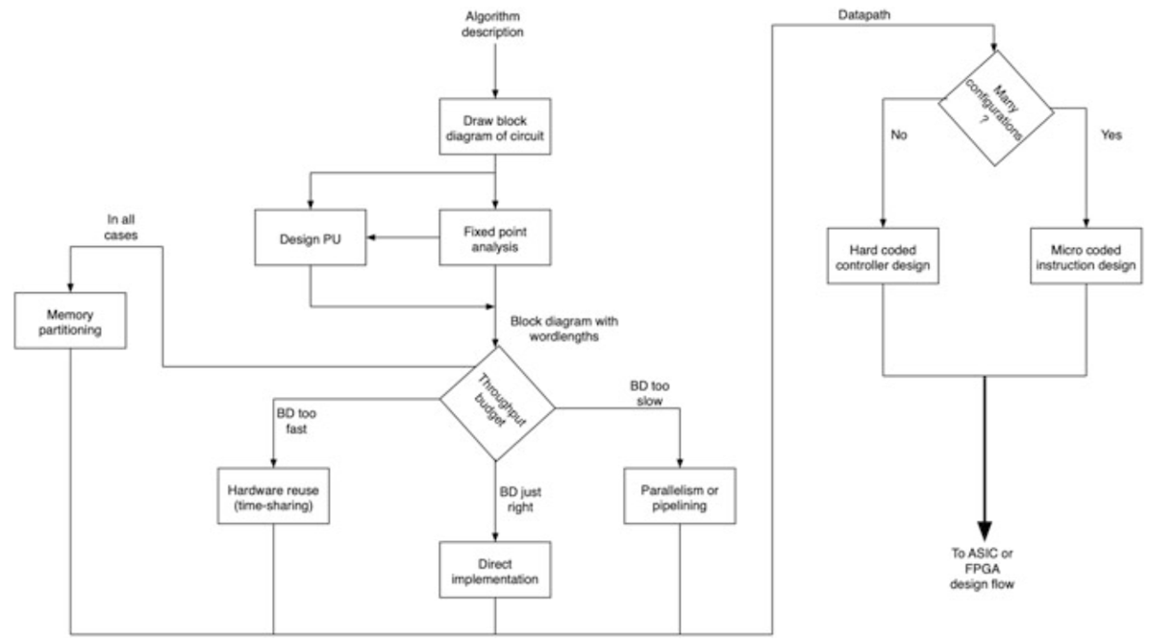
- Direct Implementation $→$number of PUs is equal to the number of operations.
- Parallelism $→$number of PUs is more than the number of operations.
- Resource sharing $→$number of PUs is less than the number of operations.
- Example:
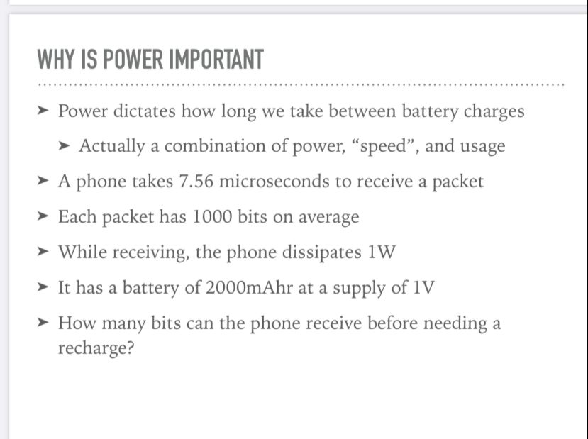
Answer:
